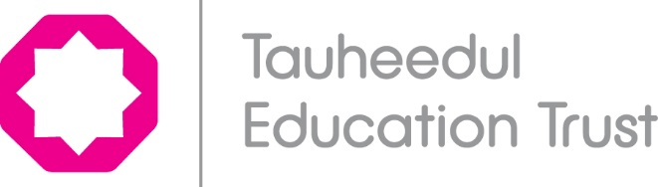

Privacy Notice (Pupils)

Data Protection Act 1998: How We Use Pupil Information

The Tauheedul Education Trust is a data controller for the purposes of the Data Protection Act.

We collect and hold personal information relating to our pupils and may also receive information about them from their previous school, local authority and/or the Department for Education (DfE). We use this personal data to:

- support our pupils’ learning;
- monitor and report on their progress;
- provide appropriate pastoral care; and
- assess the quality of our services.

This information will include their contact details, national curriculum assessment results, attendance information, any exclusion information, where they go after they leave us and personal characteristics such as their ethnic group, any special educational needs they may have as well as relevant medical information. For pupils enrolling for post 14 qualifications, the Learning Records Service will give us the unique learner number (ULN) and may also give us details about your learning or qualifications.

[for institutions with pupils 13+]
Once our pupils reach the age of 13, the law requires us to pass on certain information to [insert name of local authority or the provider of Youth Support Services in your area] who have responsibilities in relation to the education or training of 13-19 year olds. We may also share certain personal data relating to children aged 16 and over with post-16 education and training providers in order to secure appropriate services for them. A parent/guardian can request that only their child’s name, address and date of birth be passed to [insert name of local authority or the provider of Youth Support Services in your area] by informing [insert name of school administrator]. This right is transferred to the child once he/she reaches the age 16. For more information about services for young people, please go to our local authority website [insert link].

We will not give information about our pupils to anyone without your consent unless the law and our policies allow us to do so. If you want to receive a copy of the information about your child that we hold, please contact:

- [insert name/contact details of your school administrator]

To ensure effective pastoral support for all young people, we may share information with the NHS and local and national Careers Service.

We are required, by law, to pass some information about our pupils to the Department for Education (DfE). This information will, in turn, then be made available for use by the local authority.

DfE may also share pupil level personal data that we supply to them, with third parties. This will only take place where legislation allows it to do so and it is in compliance with the Data Protection Act 1998.

Decisions on whether DfE releases this personal data to third parties are subject to a robust approval process and are based on a detailed assessment of who is requesting the data, the purpose for which it is required, the level and sensitivity of data requested and the arrangements in place to store and handle the data. To be granted access to pupil level data, requestors must comply with strict terms and conditions covering the confidentiality and handling of data, security arrangements and retention and use of the data.

For more information on how this sharing process works, please visit:
https://www.gov.uk/guidance/national-pupil-database-apply-for-a-data-extract

For information on which third party organisations (and for which project) pupil level data has been provided to, please visit: https://www.gov.uk/government/publications/national-pupil-database-requests-received

If you need more information about how our local authority and/or DfE collect and use your child’s information, please visit:

- our local authority at [insert LA link to request for info];or

- the DfE website at https://www.gov.uk/data-protection-how-we-collect-and-share-research-data

