30th June 2017

Dear Parent and Carers,

**Uniform Shop**

Assalamu-Alaikum – May Peace be Upon You

I am writing to inform you about a Uniform Shop we are holding at our school.

Crossbow Schoolwear will be attending school on **Monday the 3rd and Tuesday the 4th of July from 3:20pm -4:30pm** to sell uniforms for Year 8 –Year 11. If you would like to purchase the uniform please arrange to attend during these times.

At all other times please contact

**Crossbow Schoolwear (Trutex)**

31 Broadway Market

Hackney

London E8 4PH

Tel: 020 7923 9313

For September, in response to student voice, Tauheedul Education Trust have changed the Year 7 – Year 9 hijaab from a purple hijaab to a navy hijaab with a purple headpiece as shown below.

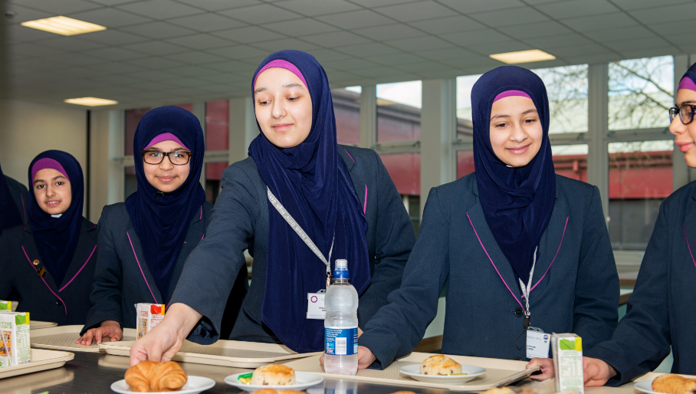

This hijaab will not be available until mid-September when the uniform supplier will receive new stock. We will inform parents of the new hijaab availability and arrange for it to be sold in school. The new hijab style is compulsory for new Year 7’s joining in September 2017. Until the new hijabs are available, the new Year 7 will be permitted to wear a navy or black pull on hijab.

Year 8 and Year 9 students will continue to wear the existing purple hijaab and change to the new style when available. The school will subsidise the cost of the new style hijaab.

For Year 10 and Year 11, who are upper school, a new navy wraparound scarf with a trim will be available from mid-September. Students will need to purchase this scarf which will be compulsory, as this change has been brought about by student voice. Again the school will subsidise the cost. Please see an image of the new hijaab below:



I would also like to remind you to apply for free school meals through the Waltham Forest Council website ([**www.walthamforest.gov.uk/freeschoolmeals**](http://www.walthamforest.gov.uk/freeschoolmeals)**)** regardless of whether or not you think you are eligible. Students who are eligible for free school meals will also be eligible for support as follows:

**Pupil Premium Guarantee**

At Eden Girls’ School, Waltham Forest, any student who has registered successfully for ‘Free School Meals’ will receive:

* Free Breakfast (each school morning), as well as lunch to the value of £2.20 each day.
* Free textbooks and stationery sold at the school.
* Free trips and outdoor educational visits (except residentials, which would be subsidised).
* £100 cheque towards the cost of uniform.

These students will also have a guaranteed place on any after-school intervention class or enrichment club that they wish to attend.

Yours sincerely



**Shahina Ahmad**

**Principal**

**Eden Girls’ School, Waltham Forest**